
TRILOBITES
Fish Have a Sixth Sense, and We're Ruining It
Most marine organisms can sense electromagnetic fields, but man-made underwater machinery is interfering with that sense.

August 16, 2026
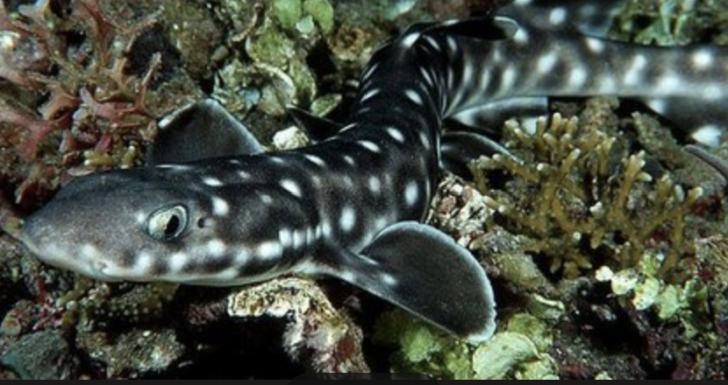

Catshark in a coral reef off the coast of the Bahamas.
Shane gross

By Rain Gatrell
Aug. 16, 2026

Most people don’t like swimming with sharks on their relaxing beach vacation, others enjoy their high speed internet from the comfort of their own homes, and most fishes enjoy migrating with their school every year. At first glance these things seem unrelated, but a deeper dive into the lives of marine organisms might change your mind.

You may have wondered how fish navigate the giant expanse of the ocean. Most marine organisms have special detectors on their body to sense electromagnetic currents produced by the earths core. These currents are also formed by other living things, as well as geographic terrain. This electromagnetic sense allows organisms to map the ocean, detect prey, follow migration paths, and find mates. This sense was first researched in the late 1990’s and not much is currently known about its how it works. Sadly, due to human interaction, this necessary biological sense may be getting negatively impacted.

In recent years, in leu of the looming threat of global warming, efforts have been made to create more sustainable renewable energy sources. Because of this, the introduction of undersea power cables were introduced. These are present along many costliness, located primarily along European costal countries. These cables produce magnetic currents, which in combination with the ever-moving ocean around them, also produce electric waves. These electromagnetic currents are sensed by local marine fauna, who rely greatly on their natural electromagnetic sense to orient themselves. These cables can produce well over 1000 G of electromagnetic current into the ocean, by comparison the earth’s crust only produces around 0.6 G.

Concerns have been raised over the potential ecological and environmental impacts this may make to local marine ecosystems. A particularly large concern is with the mating patterns of fish and marine megafauna. Overfishing has been a huge threat to ocean populations, but with an added threat of declining mating rates would completely topple the fragile balance of the marine ecosystem. Most marine animals migrate to mate, either to lay eggs or just to be in a preferred body of water. The impact of undersea electromagnetic cable emissions impacts these animals sense of direction and mapping. If they are unable to migrate to their mating location and also find their prospective mates, they may not mate at all. And these electromagnetic cables are only becoming more common with the rise in precautions against global warming.

A six-year project called “Elasmopower” examined how EMFs from subsea power cables in offshore wind farms affect sharks and rays that live near the bottom of the ocean. These species particularly rely on their electromagnetic senses to navigate in low visibility environments. Sharks, rays, dolphins and other animals have what’s called ampulla of Lorenzini, which is a specialized electroreceptor. This receptor is located in jelly-filled sensory canals that are located around the head and snout. These are used to detect even extremely small EMF signals from prey and predators, water movement, and the Earth’s natural geomagnetic field. It was discovered that the high-voltage subsea cables transmitted EMFs within the detectable range of these animals.

To further investigate this phenomenon, researchers combined long-term field measurements with laboratory experiments. In this experiment they exposed two European species, the small-spotted catshark (Scyliorhinus canicula) and the thornback ray (Raja clavate), to EMF levels similar to those near operational cables. Responses were tested across embryos, juveniles and adults to ensure consistency throughout life-stage differences. Responses were varied by species and developmental stages. Some groups appeared more sensitive than others, specific concerns were made for bottom-dwelling marine organisms such as flatfish (Pleuronectiformes), which inhabit areas around subsea cables.

The studies found reduced mating activities in the spotted catshark as well as 25% faster movement transitions when compared to control trials. For the thornback rays, their mating behaviors seemed to increase in speed, likely due to a heightened sense of stimuli around them, making them less aware of predators.

There is still more research to be done on the effects of EMFs on marine organisms, and how they may affect predator-prey interactions and mating cycles. Potential mitigation measures include burying power cables deeper in the sea flood, bundling cables to reduce the size of the EMF, and rerouting infrastructure away from sensitive habitats. It is important to note that the positive environmental impact these wind powered turbines create is not subdued by their effect on marine organisms, but rather small changes made over time and further research is necessary to make a more harmonious habitat.

Rain Gatrell is a rising 3rd year student at Northeaster University studying Marine Biology.
The Times is committed to publishing a diversity of letters to the editor. Weʼd like to hear what you think about this or any of our articles. Here are some tips. And hereʼs our email: letters@nytimes.com.
Follow the New York Times Opinion section on Facebook, Instagram, TikTok, Bluesky, WhatsApp and Threads.

References
Hermans, A. (2025). Elasmobranchs and electro-magnetic fields. Wageningen University, (1-20), https://nwwac.org/wp-content/uploads/2026/01/nwwac-march-2026-elasmopower.pdf .
N/A. (2026). Exclusion net vs shark nets. Shark Spotters: Safety Education Research Conservatoin, (1-4), https://sharkspotters.org.za/safety/exclusion-net/exclusion-net-vs-shark-nets/.
O'Connell, C. (2023). Barrier and enclosure research. Shark Mitigation Science, (1-10), https://www.sharkmitigationscience.com/barriersenclosures.
O'Connell, C. (2026). The exclusion barrier. O'Seas Conservation Foundation, (1-3), https://www.oseasfdn.org/s-projects-basic.
Rodrigo, M. (20256). Offshore wind power cables cna affect sensory system of sharks and rays: studies. Mongabay, (1-8), https://news.mongabay.com/2026/06/offshore-wind-power-cables-can-affect-sensory-system-of-sharks-and-rays-studies/ .
Rodrigo, M. (2026). Offshore wind power cables can affect sensory system of sharks and rays: studies. National Wind Watch, (1-3), https://www.wind-watch.org/news/2026/06/06/offshore-wind-power-cables-can-affect-sensory-system-of-sharks-and-rays-studies/.
Wilke, C. (2023). This discovery about dolphins isn't entirely schocking. The New York Times, (1-3), https://www.nytimes.com/2023/11/30/science/dolphins-electric-fields-sense.html.

AI Disclosure statement
No AI was used in the making of this document. The author does not even like AI in the least. The Author wishes that the AI “bubble” would pop a little sooner.

